**Prodigy’s Tale**

LOCATIONS

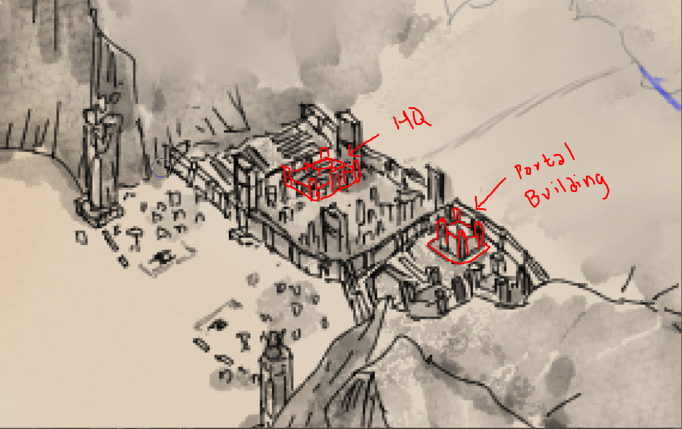*Forward Base*

*The Ehserin Town*

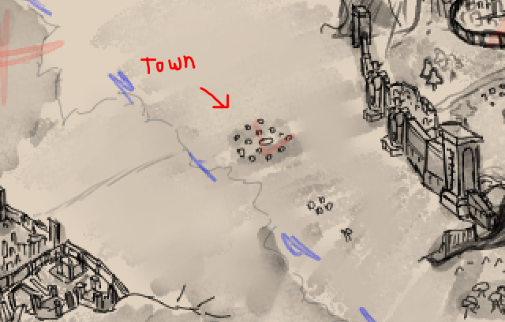

*Frontal Gate*

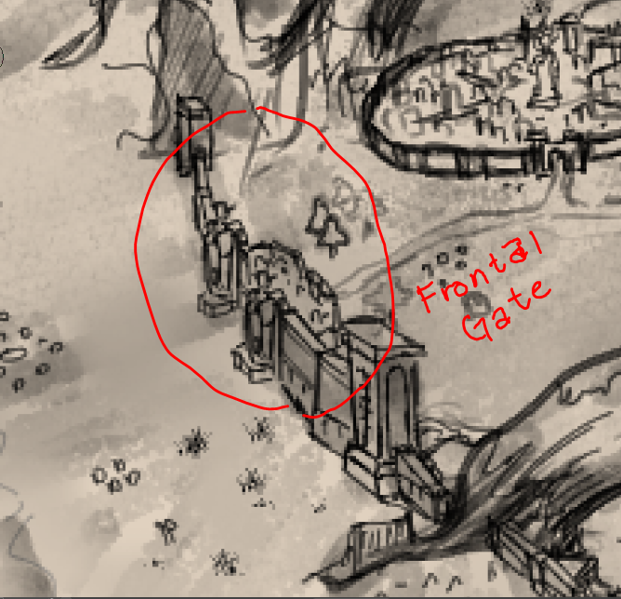

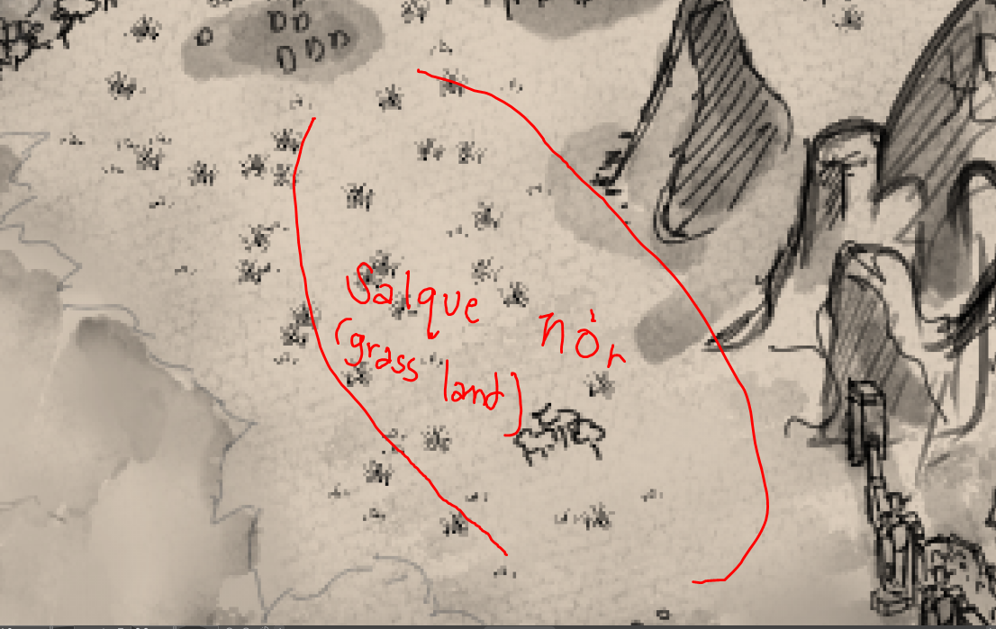*Salque nór*

*Reserve Town – Magdaline Forest - The Ei Edhil City – Synp Bridge*

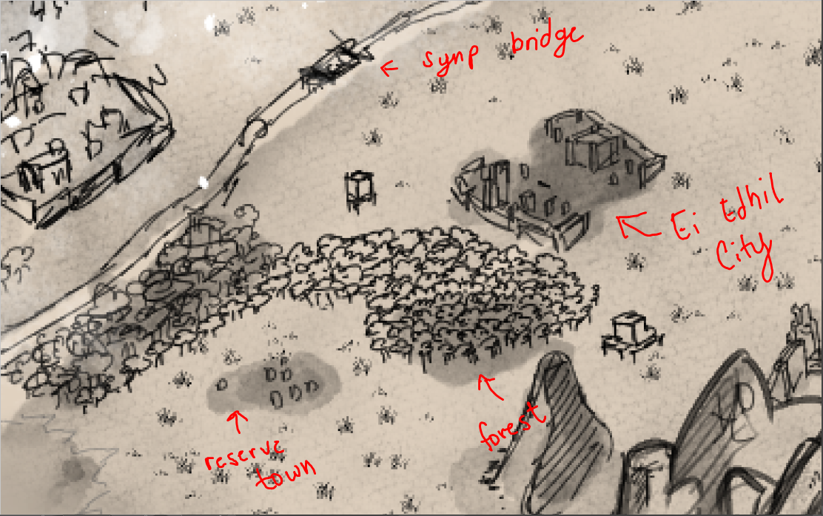

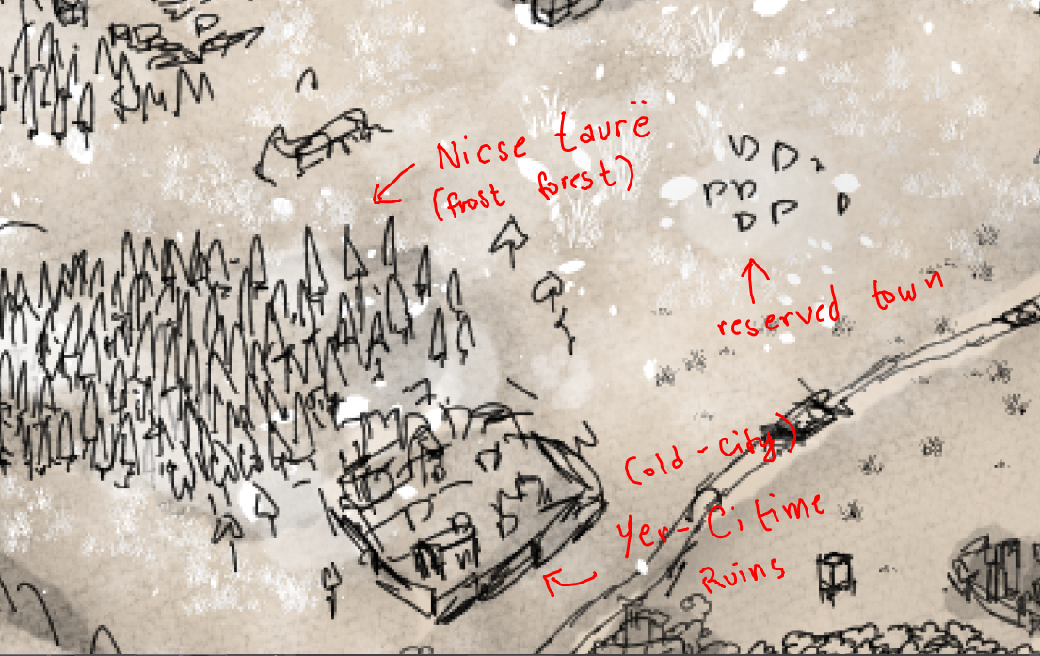

*Reserved Town – Yer-Citime and Nicse Taure*

*Nicse Callo Bastion – Lyhe Ennore City – Móre Spire - Van-Mára City – Reserve Town*

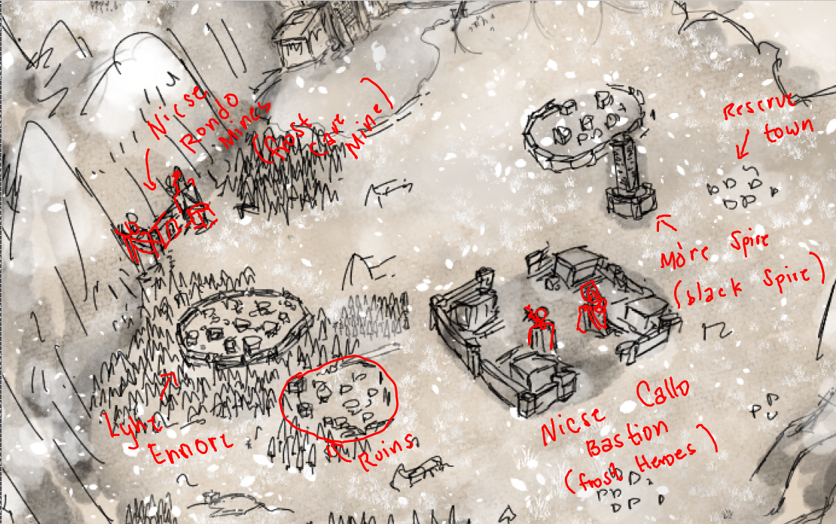

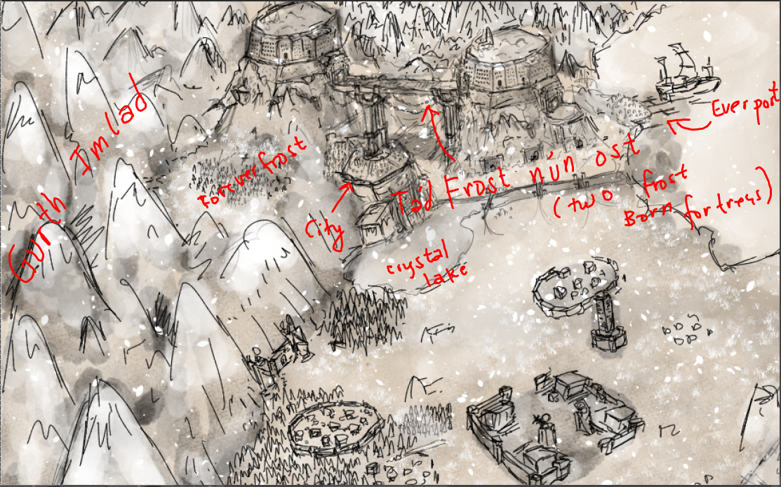*Tád Frost nún ost – Gurth Imlad (Death Valley) – Forever Frost Forest - Frost nún City – Crystal Lake - EverPort*